VISUALIZATION OF TLA+ SPECS - DESIGN AND CRITIQUES

- About TLA+ visualisations
- Visual output of the TLA+ specifications is effectively a state machine.
- We abstract a continuously evolving system into a series of discrete events. For example, the passage of time is continuous, however, it can be abstracted as the discrete advance in ticks.
- We focus first on finite state machines, meaning that the number of states is finite. We assume that the state space can be deterministically calculated.
- Effective visualisation of a state machine model, with the emphasis on the interactivity features that a visualisation can support, including filtering, aggregating, zoom in/out and detail-on-demand becomes the main objective of the project.
- State Exploration
Each state is specified by a finite list of discrete variables.
For example,
Variable a can hold the value of 1, 2, 3, 4.
Variable b can hold the value of 5, 6, 7.
Variable c can hold the value of 0, 3, 6, 9.
The total number of states is the total number of combinations of three variables, i.e. 4 x 3 x 4 = 48.
The number of states can grow very quickly, say, if there are 10 different variables, each variable can hold 10 different states. The number of states will be 10^10. Such a large structure is not practical to be understood, hence a visualisation technique that decomposes the complexity of the networks into more intuitive ways must be used.
The following parts discuss different design approaches and its critiques.
3A. Multi-level, Clustered Forced Layout with D3
Description
Each node represents a state in the network.
Each edge represents a transition from a state to another state.
Nodes are clustered together if:
- They share the same values of one or more variables (say, same varA and varB).
- Node and edge details are hidden until we zoom in/out or hover (detail on demand).
Encoding
Data | Channel
state | position
transition | link (line)
Filtering by a node value | node color

Scale
1000-10000 nodes
1000-10000 links.
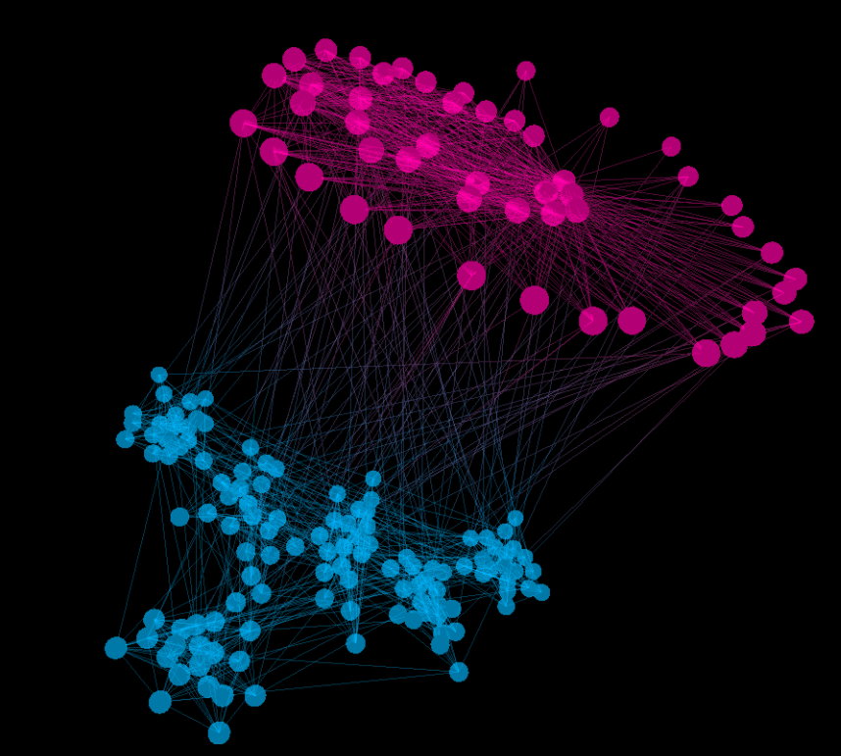
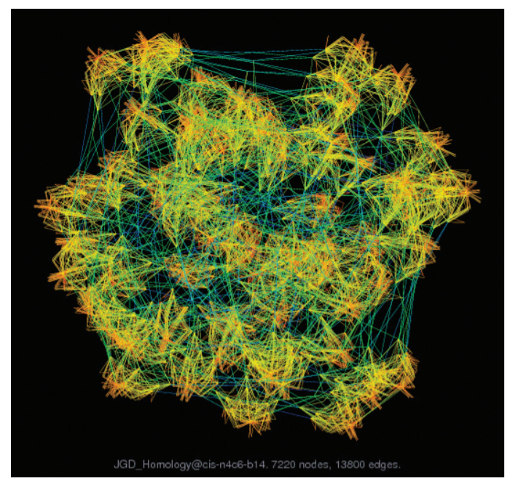
Example
VARIABLE varA, varB
Max == 3

Init == varA = 0 /\ varB = 0

IncA == (varA' = (varA+1) % Max)
IncB == (varB' = (varB+1) % Max)

Next == \/ IncA /\ UNCHANGED varB
\/ IncB /\ UNCHANGED varA
\/ IncA /\ IncB
Without clustering, the visualisation will look like this.
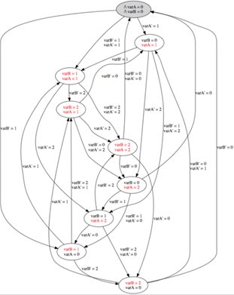

When clustering by a variable value, we can transform the above-mentioned state diagram into the one below.
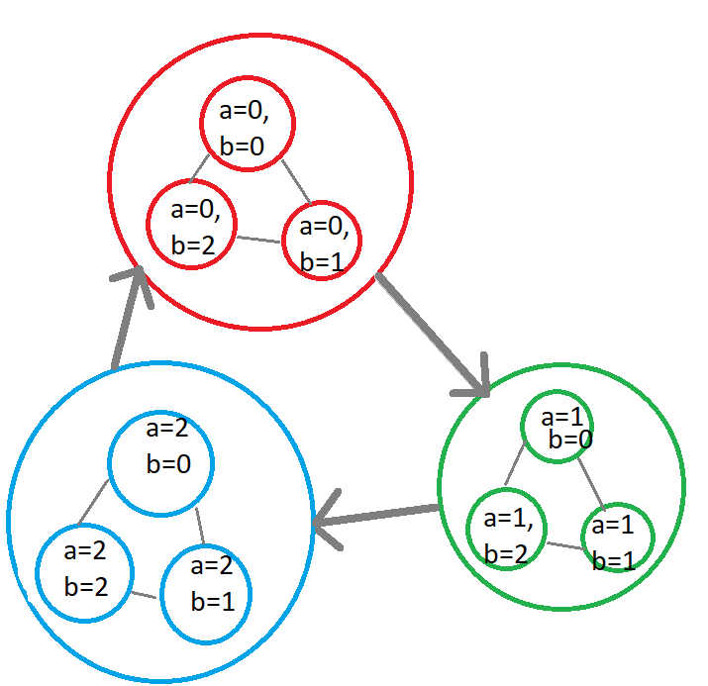
The big links that connect different clusters together represent multiple links that connect the states from one cluster to another cluster. The interactive feature should be designed in such a way that when clicking at the big links, the member links that constitute the clicked links will be expanded.

Advantages:
- Intuitive, easy to explore
- Effectively recognize the group of states that share the same variable values.
Disadvantages
- Still suffer from the “hairball” effect - it is still hard to extract any meaningful data in case the number of nodes grow up to >10000 nodes.
3B. Matrix view
Description
Different states are laid out along both the horizontal and vertical edges.
A cell will be colored if there is a state transition from the row state into the column state.
Clustering can also be used to group the states together in case they share the same variable (like the first design).

Data | Channel
state | 2D position
transition | The cell is / is not colored
Filtering by a node value | Cell color

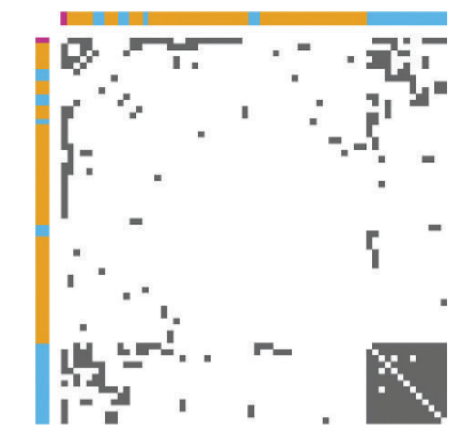

Advantages
- Can achieve high information density.
- Clustering can be detected easily.
Disadvantages
- Not as intuitive, however, some training can be done to get users used to reading the charts.

3C. Combination of both graph view and matrix view
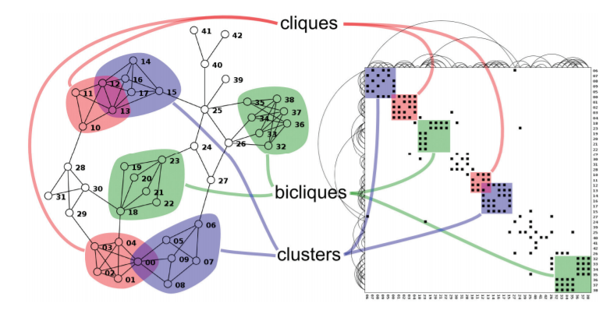
The ultimate aim is to come up with the hybrid design that takes the advantages of both the matrix view and the graph view. Such a solution is illustrated in the above graphs.

https://idl.cs.washington.edu/files/2018-TensorFlowGraph-VAST.pdf

